IPC_COFF_BLDC_230AC S05 firmware description
- MC Connection system

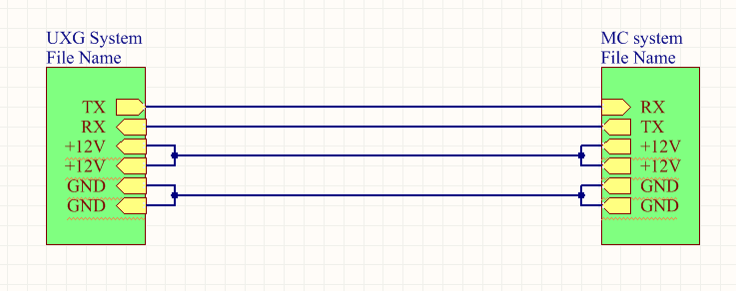

Connection method: Only the communication line and +12V power line are bridged between UXG and MC;

二、MC and MOTOR connection
Motor has 3 phase wires and a row of 5Pin Hall wires. For the method of connecting the phase wires and Hall wires to the main control board, please refer to "IPC_COFF_BLDC_230AC S04 Wiring Instructions"

三、MC opening detection interface
The MC board adds the lid opening detection function. The lid opening detection has two detections, respectively on the P1 and P2 ports on the MC board. P1 and P2 are both connected to a light-touch normally open switch. When the grinding hatch is covered 2 Each light touch is pressed down by the corresponding structure, so P1 and P2 are both connected, and the +15V voltage is supplied to the back circuit, and the motor can work normally. When the grinding chamber cover is opened, the tact switches connected to P1 and P2 are also released, and the +15V voltage cannot be supplied to the circuit behind the motor and is forced to stop driving.
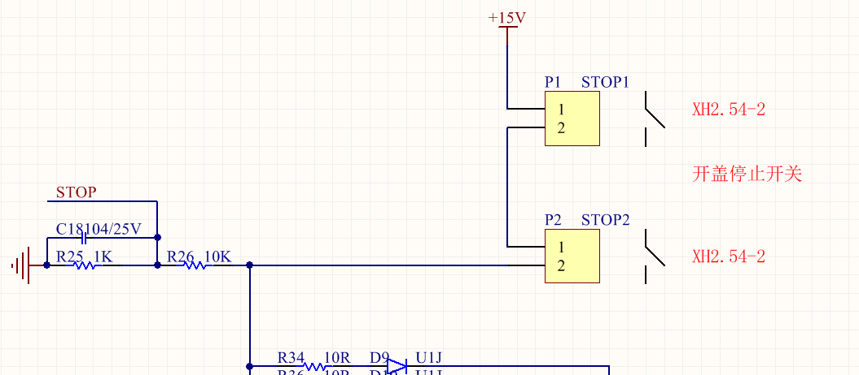
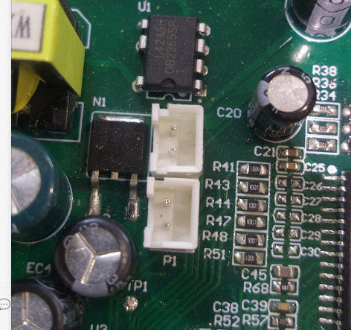

Schematic diagram of the whole machine
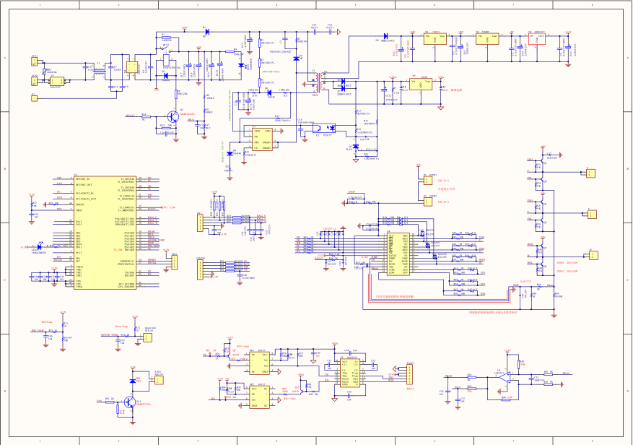

Firmware version description:
A. The new hardware version, the version number "20201122" is silk-printed on the PCB
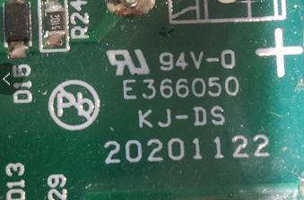

B. New software version: S05, the firmware version uses the file name definition "ebldc_mc_s05"

S05 software and S04 software update comparison:
- S05 adds grinding hatch detection function
- S05 modifies the PID parameters of the current limiting loop, and reduces Kp and Ki of S05;
- The S05 hardware overcurrent protection value is increased to 42A.
- S05 modify the content of the communication protocol
- Modification of the active state activation method. S04 enters the inactive state after 5S without a correct communication response, but returns to the active state at any time in the middle. Change to S05 to enter the inactive state after 5S without a correct communication response, and cannot be restored. , It can only be restored after power-on again;
- The communication protocol is written in accordance with "HEM-EKX-HMI-MotorControlInterfaceSpecification-100-003"
- Command 0x03 adds corresponding command execution function, supports motor temperature query command 0x07, IPM temperature query command 0x08, motor speed/current query command 0x09, DCBUS voltage query command 0x0A.
- Increase the motor start conditions, S04 needs to meet the current fault-free and soft start completion, and increase the signal for opening the hatch without grinding;
E. After the inactive state, MC is not receiving any messages;
F. Add message 0x00 to its own status feedback. When MC has a status change, MC will send a status message at a frequency of at least 1 Hz. This message is a cyclic command without a retransmission mechanism;
G. Modify the content of message 0X09, and add current and speed data by "HEM-EKX-HMI-MotorControlInterfaceSpecification-100-003";
H. Increase the message 0x07, 0x08, 0x09 automatic retransmission mechanism;
I. Increase the ID of each message. The ID of S04 is fixed 0x00, and S05 is modified to the ID of the non-retransmitted message to increase automatically. The ID of the retransmitted message remains the same as the ID of the retransmitted message.

